Sustainable Public Procurement-fiche: basic

1) Subject matter

- Food and beverages from organic food production and produced in an environmental friendly manner

OR / AND

- Food and beverages that guarantee a fair price to the producer op the products (fair trade)

“For <…..> (name of the public authority), the care for the environment and social aspects is important. It is stated in her <strategic policies>, <mission>, <vision>, <procurement policy>, …”

[Cfr. Council of the European Union; Review of the EU Sustainable Development Strategy: “Member States should support information campaigns […] to promote sustainable products inter alia products that stem from organic farming and fair trade as well as environmentally sound products.”]

2) Exclusion criteria

Non compliance with environmental and social legislation, which has been the subject of a final judgment or a decision having equivalent effect, may be considered an offence concerning the professional conduct of the economic operator concerned or grave misconduct, permitting to exclude the party concerned from competing for the contract

Ref:
Art. 53 and 54 of Directive 2004/17/EC and Art. 45 of Directive 2004/18/EC

3) Technical capacity (not exclusive)
/

4) Technical specifications

a) Organic production

To specify by the contracting authority:

- [X] % of [either a defined product group such as dairy, meat, vegetables, or a list of specific products e.g. potatoes, tomatoes, beef, eggs] must be organically produced according to Regulation (EEC) No 2092/91 until 31 December 2008, and Regulation (EC) No 834/2007 as of 1 January 2009.

[EU toolkit: core criteria]

b) Packaging

To specify by the contracting authority:

State a percentage of products that:
• Are supplied in secondary and/or transport packaging with more than 45% recycled content.
• Are not supplied in individual portions (single-unit packages).

[EU toolkit: core criteria]

Evidence

The compliance with the criteria a), first criterium can be proved with one of the following labels:
Europe:  Holland:  Germany: 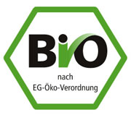

France:  UK: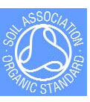 Belgium: 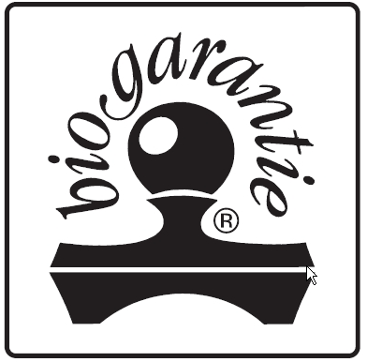
or any other national recognised label on organic food production, or equivalent certificates from the supplier

5) Awarding the contract:

 | Criterium | Weight
1 | Price  Calculation (e.g.): Lowest offered price/ stated price x 0,70 | e.g. 70%
2 | Environmental criteria  (The public authority formulates the points it wants to assign to the below mentioned criteria )  Calculation (e.g.): Total scored points / maximum number of points x 0,20 | e.g. 20%
3 | … | e.g. 5 %
4 | … | e.g. ….

Environmental criteria

Organic food

To specify by the contracting authority:

- Additional share of products coming from organic sources above the minimum requirement in the above stated specifications.

[EU toolkit: core criteria]

6) Performance clauses
/

6bis) Specific performance clauses

(if relevant for your procurement, particularly for products originating from the international trade or from developing countries)

(ref. Belgian Program Law: 8e April 2003, art. 102)

Note: for more information about the concepts of fair trade and ethical trade, see
Communication from the Commission to the Council, the European Parliament and the European Economic and Social Committee: Contributing to Sustainable Development: the role of Fair Trade and non-governmental trade-related sustainability assurance schemes.
(COM(2009) 215 final and Council of the European Union the 8e May 2009)

Fair trade aspects:

- The tenderer ensures that producers of the product receive a price which reflects an adequate return on their input of skill, labour and resources, and a share of the total profit commensurate with their input. This is normally effected through an agreement by the participants in the fair trade initiative to pay a fair price which is negotiated on a case by case basis. In situations where the price of goods is agreed internationally (e.g. coffee and cocoa), a minimum price is set so that producers receive a return above the world price for their produce. This enables producers to adopt improved production systems and working conditions to the benefit of farmers and workers and the environment.
- The tenderer states in his offer how the compliance with the specific performance clauses will be guaranteed. Also, he mentions the evidence that can be presented to warrant the compliance. A label of one of the members of the Fairtrade Labelling Organizations (FLO) International (e.g.. Max Havelaar) or World Fair Trade Organization (WFTO) can be such a proof:

. 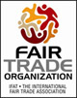 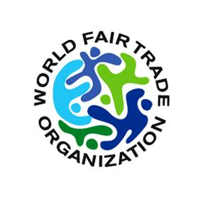

Also any other evidence delivered by an independent institute, supported by a government, is valid.

References

[Information of the public authority that used these clauses in a procurement case]

