Sustainable Public Procurement-fiche :advanced

1) Subject matter

- Catering service with food and beverages from organic food production and produced in an environmental friendly manner

OR / AND

- Catering service with food and beverages that guarantee a fair price to the producer op the products (fair trade)

“For <…..> (name of the public authority), the care for the environment and social aspects is important. It is stated in her <strategic policies>, <mission>, <vision>, <procurement policy>, …”

[Cfr. Council of the European Union; Review of the EU Sustainable Development Strategy: “Member States should support information campaigns […] to promote sustainable products inter alia products that stem from organic farming and fair trade as well as environmentally sound products.”]

2) Exclusion criteria

Non compliance with environmental and social legislation, which has been the subject of a final judgment or a decision having equivalent effect, may be considered an offence concerning the professional conduct of the economic operator concerned or grave misconduct, permitting to exclude the party concerned from competing for the contract

Ref:
Art. 53 and 54 of Directive 2004/17/EC and Art. 45 of Directive 2004/18/EC

3) Technical capacity (not exclusive)

The contractor must prove its technical and professional capability to perform the environmental aspects of the contract through:
- an environmental management system (EMS) for catering services (such as EMAS, ISO 14001or equivalent, [insert other national or regional official systems]), or
- an environmental policy for catering operations and work instructions and procedures for carrying out the service in an environmentally friendly way, or
- previous experience in applying environmental management measures in similar contracts
[EU toolkit: comprehensive criteria]

4) Technical specifications

a) Food

To specify by the contracting authority:

- [X] % of [either a defined product group such as dairy, meat, vegetables, or a list of specific products e.g. potatoes, tomatoes, beef, eggs] must be organically produced according to Regulation (EEC) No 2092/91 until 31 December 2008, and Regulation (EC) No 834/2007 as of 1 January 2009.

[EU toolkit: core criteria]

- Of the remaining non-organic produce, [X] % of [either a defined product group such as dairy, meat, vegetables, or a list of specific products e.g. potatoes, tomatoes, beef, eggs] must be produced in accordance with the criteria of Integrated Production or equivalent systems.

[EU toolkit: comprehensive criteria]

- [In cases where the contracted company defines the menus] The main fruit, vegetables and marine products to be used in carrying out the service shall, whenever possible, be selected according to the season based on the geographical location in which the assignment is performed. The recommended guidelines are found in the seasonal calendar in Annex X [to be developed by the contracting authority].

[EU toolkit: core criteria]

b) Paper products

Paper products, such as kitchen paper or paper napkins, to be used in carrying out the service must be made from recycled or sustainably managed virgin fibre.

[EU toolkit: comprehensive criteria]

Evidence

The compliance with the criteria a), first criterium can be proved with one of the following labels:
Europe:  Holland:  Germany: 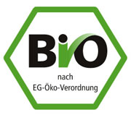

France:  UK: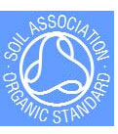 Belgium: 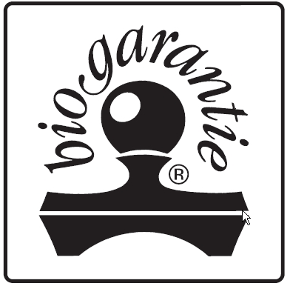
or any other national recognised label on organic food production, or equivalent certificates from the supplier

5) Awarding the contract:

 | Criterium | Weight
1 | Price  Calculation (e.g.): Lowest offered price/ stated price x 0,70 | e.g. 70%
2 | Environmental criteria  (The public authority formulates the points it wants to assign to the below mentioned criteria )  Calculation (e.g.): Total scored points / maximum number of points x 0,20 | e.g. 20%
3 | … | e.g. 5 %
4 | … | e.g ….

Environmental criteria

a) Organic food

To specify by the contracting authority:

- Additional share of products coming from organic sources above the minimum requirement in the above stated specifications.

[EU toolkit: core criteria]

- Integrated Production
Additional share of products coming from Integrated Production sources above the minimum requirement in the specification.

[EU toolkit: comprehensive criteria]

b) Aquaculture and marine products

To specify by the contracting authority:

Proportion of aquaculture and marine products (as compared to the total volume of aquaculture and marine products purchased) to be used in carrying out the service which are caught or produced through sustainable practices and methods as defined in a relevant label for sustainable fishing and aquaculture.

[EU toolkit: comprehensive criteria]

c) Animal welfare standards

To specify by the contracting authority:

- State the proportion of animal products which is produced with high welfare standards according to national guidelines.

[EU toolkit: comprehensive criteria]

d) Packaging

To specify by the contracting authority:

State the percentage of products that:
- Are supplied in secondary and/or transport packaging with more than 45% recycled content.
- Are not supplied in individual portions (single-unit packages).

[EU toolkit: comprehensive criteria]

e) Equipment
The following criteria must be met:
- Refrigerators and freezers to be used in carrying out the service are free of ozone-depleting substances (HCFCs) and HFCs.
- The equipment used meets one or more of the following energy efficiency standards where such standards exist: Energy Star, EU energy label (classification A), or [other national standards] or equivalent.
- The equipment used is water efficient according to the EU label (classification A) or equivalent standards.
[EU toolkit: comprehensive criteria]

f) Cleaning products
The cleaning products to be used in carrying out the service must meet the following criteria: (insert Core criteria from the Cleaning Products and Services Product Sheet).

[EU toolkit: comprehensive criteria]

6) Performance clauses

a) Waste generation
• In order to reduce waste generation, food and beverages must be served using reusable cutlery, glassware, crockery and tablecloths.
• Waste produced in carrying out the service will be collected separately according to the collecting system of the public administration, which includes the fractions
of [define here the specific waste fractions to be separately collected, depending on local administrative rules].
[EU toolkit: core criteria]

b) Transport
The vehicles to be used in carrying out the service shall at least fulfill the exhaust emission requirements of EURO 3 or III (this means that vehicles shall be from at least 2000/2001 or have been retrofitted to comply with such emission levels).
Suppliers must provide a list of the vehicles to be used in carrying out the service and the respective technical sheets of these vehicles which state the relevant emission levels.
[EU toolkit: core criteria]

c) Staff training
The catering staff must be trained in waste minimization, management and selective waste collection as well as in product information (origin, environmental and social quality of the products). The contractor will present a training plan once the contract is awarded and, at the end of the contract, a certificate stating the training undertaken by both new and permanent staff will be submitted to the contracting authority.
[EU toolkit: comprehensive criteria]

d) Service management

[If selection criteria are not included] The contractor shall endeavour to ensure that, where possible, food used in carrying out the service is produced in a manner that minimizes adverse environmental impacts. Therefore within the first 6 months of the contract, the contractor will have structured and documented environmental procedures for at least the following areas:
• Evaluation of the most significant environmental aspects of the service provided.
• Food selection, manipulation and conservation.
• Waste minimization and selective collection.
• Reduction of energy and water consumption in food preparation and transport.
• Training.
[EU toolkit: comprehensive criteria]

6bis) Specific performance clauses

(if relevant for your procurement, particularly for products originating from the international trade or from developing countries)

(ref. Belgian Program Law: 8e April 2003, art. 102)

Note: for more information about the concepts of fair trade and ethical trade, see
Communication from the Commission to the Council, the European Parliament and the European Economic and Social Committee: Contributing to Sustainable Development: the role of Fair Trade and non-governmental trade-related sustainability assurance schemes.
(COM(2009) 215 final and Council of the European Union the 8e May 2009)

Fair trade aspects:

- The tenderer ensures that producers of the product receive a price which reflects an adequate return on their input of skill, labour and resources, and a share of the total profit commensurate with their input. This is normally effected through an agreement by the participants in the fair trade initiative to pay a fair price which is negotiated on a case by case basis. In situations where the price of goods is agreed internationally (e.g. coffee and cocoa), a minimum price is set so that producers receive a return above the world price for their produce. This enables producers to adopt improved production systems and working conditions to the benefit of farmers and workers and the environment.
- The tenderer states in his offer how the compliance with the specific performance clauses will be guaranteed. Also, he mentions the evidence that can be presented to warrant the compliance. A label of one of the members of the Fairtrade Labelling Organizations (FLO) International (e.g.. Max Havelaar) or World Fair Trade Organization (WFTO) can be such a proof:

. 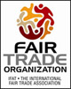 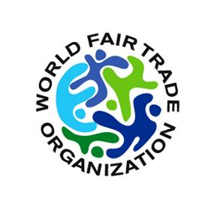

Also any other evidence delivered by an independent institute, supported by a government, is valid.

References

[Information of the public authority that used these clauses in a procurement case]

